**Skin Cancer Detection from Dermascopic Images using Convolutional Neural Networks (CNN)**

**Saraswata Mangal1, C. P. Koushik2**

**mangalsaraswata@gmail.com,cpkoushik@gmail.com**

***Student, School of Computer Science Engineering 1;Assistant Professor, School of Computer Science Engineering.2***

***VIT Bhopal University, Kothrikalan, Sehore, Madhya Pradesh – 466114, India***

**Abstract:**

Skin cancer is one of the most rapidly spreading illnesses in the world and because of the limited resources available, poses a significant global health challenge, necessitating early and accurate diagnosis for improved patient outcomes. Traditional diagnostic methods face limitations in terms of efficiency and subjectivity. Leveraging deep learning methodologies,such as CNN has emerged as a promising avenue to assist dermatologists in achieving more precise and timely diagnoses. Utilizing the HAM10000 dataset, comprising diverse skin lesion types, this research undertakes comprehensive data preprocessing techniques, including robust sampling methodologies and meticulous feature extraction.The Xception model is employed for training and evaluation, leveraging transfer learning techniques to exploit the model's pre-trained weights and adapt them to the skin cancer detection task.The research focuses on achieving multiple objectives: (i) establishing a robust skin cancer detection system using the Xception model, (ii) addressing the class imbalance problem inherent in skin lesion datasets, and (iii) exploring optimization functions and activation functions to enhance model performance.Evaluation of the proposed system's performance involves comparative analysis with existing classifiers, measuring generalization capability and classification accuracy.

**Keywords** : Skin Cancer, images,Neural Network

1. **Introduction:**

Skin cancer, which is the most prevalent cancer nowadays is the result of abnormal skin growth and can be divided into two types : cancerous and non-cancerous . Malignant tumors are those types of tumors that can grow and spread to other areas of the body, while a benign tumor can form but does not spread easily. There are two main There are various factors which can lead to skin cancer such as smoking; prolonged exposure to ultraviolet radiation; fairskin, light-colored eyes, hair that are vulnerable to ultraviolet radiation; sunburns or prolonged sun exposure; history of skin cancer in family; light drinking alchohol, infections , pollution and other environmental factors. The skin cancer lesion which is the most dangerous is melanoma while the most common one is basal cell carcinoma.

If cancer is detected from dermascopic images in advance it will severly increase the chances of survival of a patient. Non invasive skin imaging technique dermascopy uses a magnified and lighted picture of the affected skin area to increase visibility of the spots. However doctors face a significant difficulty in identifying skin cancer from these dermascopic images as most of the skin lesions look similar. Thus, it can lead to late diagnosis which can be very harmful for the patient. Early detection of skin cancer is essential for improving treatment outcomes, preventing metastasis, minimizing morbidity, reducing healthcare costs, and promoting public health. Timely screening, prompt diagnosis, and early intervention are key strategies in the fight against skin cancer, ultimately saving lives and improving the quality of life for individuals affected by this disease.

In recent times convolution neural networks have been proven to be the most effective method by which we can identify skin cancer from dermascopic images. Different CNN models have been deployed in medical diagnostics because of their ability to detect patterns in digital images. Their ability to learn complex patterns from raw data has the potential to transform healthcare by enabling more accurate, efficient, and personalized diagnosis and treatment strategies. This has addressed the constraints and limits of the traditional clinical evalution using biopsy. In this research paper we will try to classify seven types of skin lesions as given in the images below.

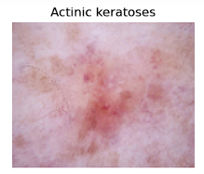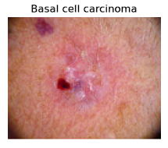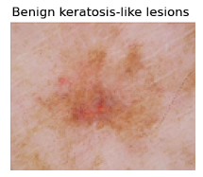

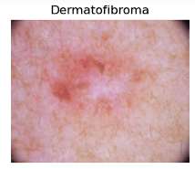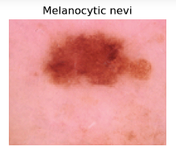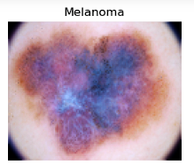

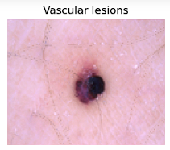

**Figure1:Images for all types of skin lesions in the dataset**

These images from the dataset are then used to train the Xception model which will then classify the images, into the correct types.

1. **Literature Review :**

Numerous scholars have suggested using image-based processing techniques to diagnose skin conditions. In a paper by Mahbod et al.[1] they suggested a structure for a multi-class dermascopic system of skin diseases. Models such as AlexNet, VGG16 a nd Resnet18 were used to characterize skin lesions images. They used intricate images of the ISIC 2017 dataset and achieved a accuracy of 90.63 percent.

In their study, Zia et al.[2] investigated the use of deep learning models for skin cancer diagnosis. They achieved improved accuracy by integrating extra convolution layers into two pre-trained models, MobileNetV2 and DenseNet201. The DenseNet201 model achieved the highest accuracy of 95.50% in recognizing benign and malignant skin lesions. The models were trained on an updated Kaggle dataset from the ISIC repository, which included both benign and malignant classifications. Data augmentation with 0.1 variance Gaussian noise was used. At the end, the study found that the modified DenseNet201 model was more effective than the modified MobileNetV2 model for skin lesion classification.

Gouda et al.[3] in a study used a custom CNN model to classify between malign and benign tumors. Images to be used for the classificatio were improved using ESGRAN method, which was then preprocessed. They used multiple pretrained models like Resnet50, InceptionV3 and InceptionResnet to fine tune the model. The accuracy obtained by their model is 83.2% as opposed to Resnet50(83.7%), InceptionV3(85.8%) and InceptionResnet(84%). The dataset used by them is the ISIC 2018 datset.

Fu'adah et al.[4] in their study used a custom CNN model which uses 3 pairs of conv and maxpooling layers with ReLU activation layers. They experimented with several optimizers using 0.001 learning rate with Adam turning out to be the best one. The accuracy obtained with Adam as optimizer is 99% and precision, recall and f1-score is close to 1. The dataset used is the ISIC dataset. The goals of the project were to develop a method for distinguishing benign tumor lesions from skin cancer and increase the efficiency and accuracy of classification.

In a paper by Hagerty et al .[5] a custom model using deep learning and handcrafted features was used to obtain high accuracy for melanoma detection. The custom model obtained a AUC score of 0.94 compared to the score of 0.83 of the Resnet model. The dataset used were the NIH SBIR dataset which consists of 1636 images and the ISIC dataset.

Tschandl et al. [6] in their study proposed a framework designed for multi-class dermoscopy of skin lesion images. Pretrained CNN models such as AlexNet, VGG16, and ResNet18 were used to obtain the results. The accuracy obtained is 90.63% and the dataset used is the ISIC 2017.

Fujisawa et al.[7] in their study used a predictive framework for skin disease classification. Pretrained CNN models such as LeNet,AlexNet, ZFNet, VGGNet, GoogLeNet, ResNet, or SENet was used in this endeavor. The data used was images from 1842 patients from the University of Tsukaba Hospital. The overall accuracy obtained was 76.5%. The sensitivity obtained was 96.3% and the specificity was 89.5%.The highest accuracy obtained by the model was 92.4% while the highest accuracy of a board certified dermatologist was 85.3%.

Pacheco et al.[8] in a study used computer aided diagnosis to detect skin lesions. A biopsy-proven dataset known as PAD-UFES-20 was used in this study. The best model found during the experiments was Resnet50 which performed 4% above the rest of the models performance. The models performance was based upon controlling the the amount of information being passed as feature maps in the hidden layers.The accuracy obtained by the Resnet50 model is around 78.8% and AUC score is around 0.958.

Using a deep learning framework as a foundation, Maqsood et al.[9] developed a unified CAD model. With this method, thermoscopic images are preprocessed via multiple exposure fusion and contrast enhancement. Skin lesion segmentation is done using a custom 26-layer CNN, and then transfer learning is done on pre-trained Xception, ResNet-50, ResNet-101, and VGG16 models. Convolutional sparse image decomposition is used to fuse deep features, and univariate measurement and Poisson distribution are used for feature selection. A multi-class support vector machine is used to classify the chosen features (MC-SVM). Using the HAM10000, ISIC2018, ISIC2019, and PH2 datasets, the suggested method outperformed earlier efforts in terms of accuracy, obtaining 98.57%, 98.62%, 93.47%, and 98.98%, respectively.

The work of Krishna Mridha et al.[10] offers a comprehensive approach to addressing important challenges in skin cancer detection. Their work addresses the significant class imbalance issue present in skin lesion datasets while concentrating on building reliable prediction models for the classification of skin cancer. Their research achieves notable classification accuracy of 82% and minimal loss accuracy of 0.47% by using an optimized convolutional neural network (CNN) architecture trained on the HAM10000 dataset. Notably, the authors go above and beyond the creation of models by putting forth an Android application that proposes an End-to-End smart healthcare system that will be useful for diagnosing skin cancer in its early stages. Moreover, the incorporation of explainable AI methods such as Grad-CAM and Grad-CAM++ enhances the interpretability of the model by offering insights into its decision-making process.

1. **Methods:**
   1. **How does a Neural Network Work**

Neural Network is a Deep Learning method which uses interconnected nodes structured like a human brain. They are used to solve various problems in the field of Artificial Intelligence, as they can learn and model the relationships between various types of data.

Neural network consists of 3 layers :

**Input Layer**

We provide information to the Neural Network through the input layer, which passes it to the next layer after analysing and categorising the data.

**Hidden Layer**

Hidden layers take their input from the either the input layer or from other hidden layers. Neural Networks can have a large number of hidden layers and each hidden layer processes the output from the previous layer, and passes it on to the next layer.

**Output Layer**

The output layer gives the final result of all the artificial neural network. It can have single or multiple outputs.

## ****Back-Propagation****

Backpropagation is the process of computing the error(loss), and feeding it back to the neural network and update parameters of each neuron. During every epoch the model adjusts the parameters(weights and biases) during gradient descent. It tries to move towards the global minima and which will make the cost function have the minimum value that will give us the optimum model. We use partial derivates from calculus to obtain the optimum values for the parameters.

For example, we are working with a neural network model based on logistic regression. Then the loss function for a input will be a log function:

(1)

Where, y = true value for a input ; ŷ = predicted value of the input

The above equation is for a single input . Now the cost function for a feature column for the entire dataset is :

(2)

Where , N = total number of inputs

We represent the weights by W and bias by b . Thus after calculating the cost function we will update the weights and bias by the following equations :

(3)

(4)

Where , Wn = previous weight value ; bn = previous bias value ; Wn+1= updated weight value; bn+1= updated bias value ; α = learning rate

Initially we assign a random value to the parameters and then we update them step by step after every epoch . Here, learning rate suggests the minimum steps taken by the model to descend to the minima.

* 1. **CNN Model working:**

Convolution Neural Network(CNN) is a type of neural network which is mostly used in image or pattern recognition. CNN consists of the following layers :

* **Input Layers:** It is the layer where we provide input to our model. The input can be either an image or a sequence of images.
* **Convolutional Layers:**This layer is used for extracting features from the input data. It applies a set of learnable filters known as kernels to the input images. The filters are smaller matrices usually 3×3, or 5×5 shape, that slides over the image matrix and computes the dot product between kernel matrix and the corresponding image matrix. We can use an activation function to provide nonlinearity to the layers, which is sometimes called an activation layer,eg. ReLU, Tanh, sigmoid.
* **Pooling layer:** This layer helps to reduce the size of volume which makes the computation fast, which reduces memory and prevents overfitting. Two common types of pooling layers are max pooling and average pooling.
* **Flattening layer:**The feature maps after passing through many iterations of conv layers and pooling layers flattened into a 1-D vector, which can be used for classification/regression.
* **Fully Connected Layers:**It takes input from the flattening layer and completes the final classification/regression .
* **Output Layer:** The output from the fully connected layer is then used for providing the final outcome.

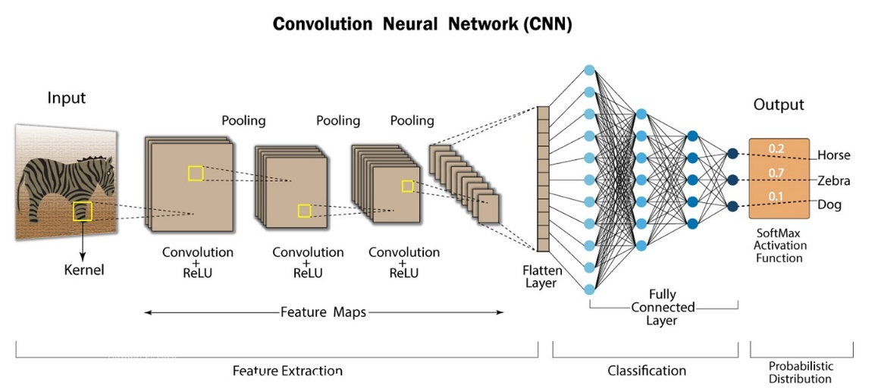

**Figure 2 : Architecture Diagram of CNN**

* 1. **Dataset Description:**

The dataset we are using is the HAM10000 dataset. This dataset incudes 10015 dermascopic images of seven different categories of skin lesions.This also contains a csv file which conatains patient metadata. The seven types of leisons are Acitinic keratoses, Basal cell carcinoma, Benign keratosis-like lesions, Dermatofibroma, Melanocytic nevi, Melanoma, and Vascular lesions.

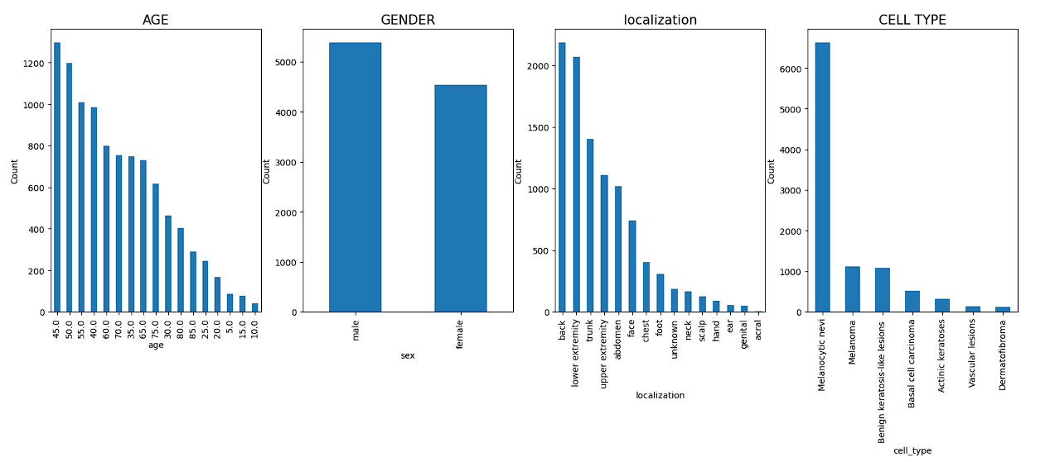

**Figure 3 : Description of HAM10000 dataset**

Skin illnesses are viewed as greatest in individuals matured around 45. Least for 10 and underneath. As the age expands the likelihood of having skin sicknesses additionally inceases. Skin illnesses are more unmistakable in Men when contrasted with Ladies and other orientation.Skin illnesses are noticeable significantly more on the rear of the body contrasted with the acral surfaces like appendages, fingers, or ears.Melanocytic nevi is the most generally happening infection, while the most un-normal is Dermatofibroma.

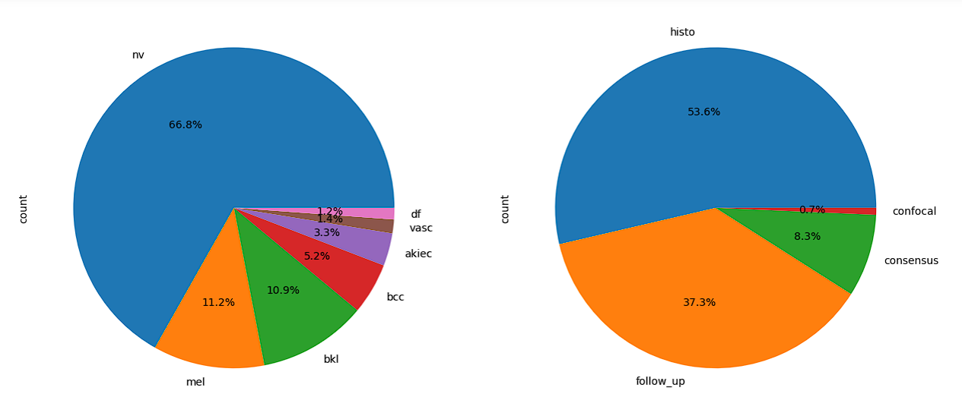

**(a) (b)**

**Figure 4:(a) Distribution of the types of skin lesion in the dataset. (b) Distribution of**

**diagnostic processes.**

The distribution of skin diseases among patients reveals that melanocytic nevi (nv) constitute the majority at 69.9%, followed by melanoma (mel) at 11.1%, and benign keratosis-like lesions (bkl) at 11.0%. Basal cell carcinoma (bcc) accounts for 5.1% of cases, while actinic keratoses (akiec) represent 3.3%. Vascular lesions (vasc) are less common, comprising 1.4% of diagnoses, and dermatofibroma (df) is the least prevalent at 1.1%. This data underscores the varying prevalence and importance of different skin conditions within the studied population.

The discovery of the skin disease predominantly relied on histopathology, comprising 53.3% of the diagnostic process, indicating the significance of examining tissue samples microsco-pically for identifying pathological changes. Follow-up examinations contributed significantly, at 37.0%, suggesting the importance of monitoring the progression or regression of sympto-ms over time to better understand the disease's nature. Expert consensus played a minor role, accounting for 9.0% of the diagnostic process, indicating that collaborative expertise was occasionally sought to confirm findings or interpretations. Confirmation through in-vivo confocal microscopy made up only 0.7% of the diagnostic process, suggesting a limited role in the specific case, likely due to its applicability in certain types of skin conditions.

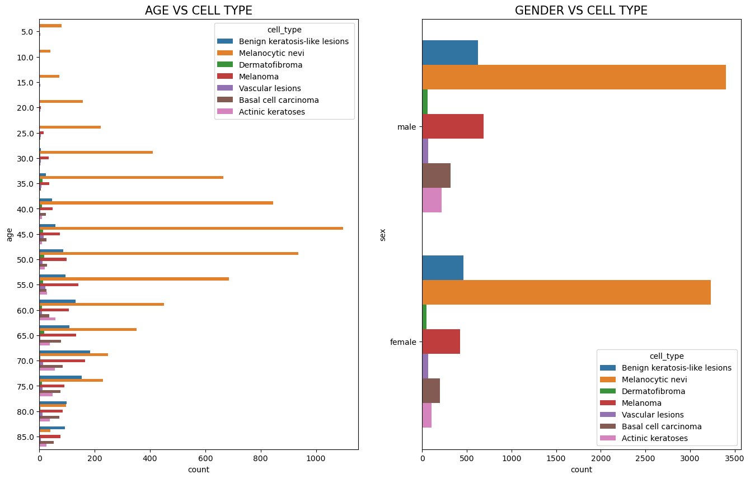

**(a) (b)**

**Figure 5 : (a) Count Plot for the number of skin lesion types based on age.**

**(b) Count Plot for the number of skin lesion types based on gender**

* 1. **Data Preprocessing:**

First we resize the images from their original dimensions to smaller dimension, which will make the computation faster.We split the data into train and test set in the ratio 75:25. Then we normalize the images. We perform One-Hot encoding on the labels , so that we can get a better accuracy. We perform data augementation techniques to increase the sample size , so that our training model has more data. We perform actions such as horizontal and vertical flip, shifting the images by some unit, as well as rotating them.

**3.5 Removal of Noise:**

There are many unwanted things like hair , follicles, acne which reduces the accuracy of the image. So we implement Dull Razor method to remove this unwanted noise. It distinguishes the dim hair areas by a summed up grayscale morphological shutting operation.It checks the state of the hair pixels as slim and long construction, and supplant the confirmed pixels by a bilinear interpolation.It smooths the supplanted hair pixels with a versatile middle channel.

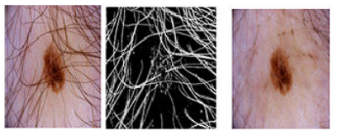

**(a) (b) (c)**

**Figure 6 : (a) Initial Image (b) Greyscale Image (c) Final Image**

* 1. **Model Implementation:**

We use the Xception model for this research.Xception is an improved version of Inception that requires fewer computational resources. Xception is a convolutional neural network (CNN) architecture characterized by its use of depthwise separable convolutions. Unlike traditional convolutional layers, which convolve across all input channels, Xception's depthwise separable convolutions split the convolution process into two stages: depthwise convolution and pointwise convolution. In the depthwise convolution stage, each input channel is convolved separately with its corresponding filter, preserving spatial information. This is followed by pointwise convolutions, where 1x1 convolutions are applied to mix information across channels. By decoupling spatial and channel-wise convolutions, Xception significantly reduces the number of parameters and computational complexity while maintaining or even improving representational capacity. This architecture achieves a better balance between efficiency and performance, making it well-suited for various computer vision tasks, including skin cancer classification.

Xception offers several advantages over traditional convolutional neural network architectures. Firstly, its depthwise separable convolutions significantly reduce computational complexity by decoupling spatial and channel-wise convolutions, leading to a more efficient use of parameters. This efficiency not only speeds up training and inference times but also makes the model more suitable for deployment on resource-constrained devices. Additionally, the reduced number of parameters helps mitigate overfitting, making Xception more robust when trained on limited datasets. Moreover, Xception's ability to capture intricate patterns and features from input images contributes to its superior performance in various computer vision tasks, including skin cancer classification. Overall, Xception's efficiency, parameter efficiency, reduced overfitting, and high performance make it a compelling choice for a wide range of applications in the field of deep learning. Xception's efficiency and performance make it well-suited for skin cancer classification tasks, particularly when dealing with large datasets and limited computational resources.

Top of Form

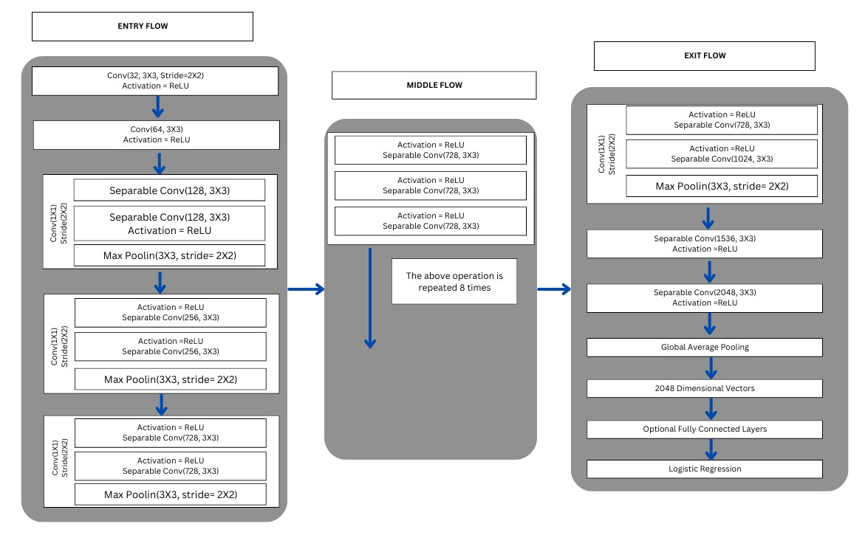

**Figure 7 : Overall Architecture of Xception CNN Model**

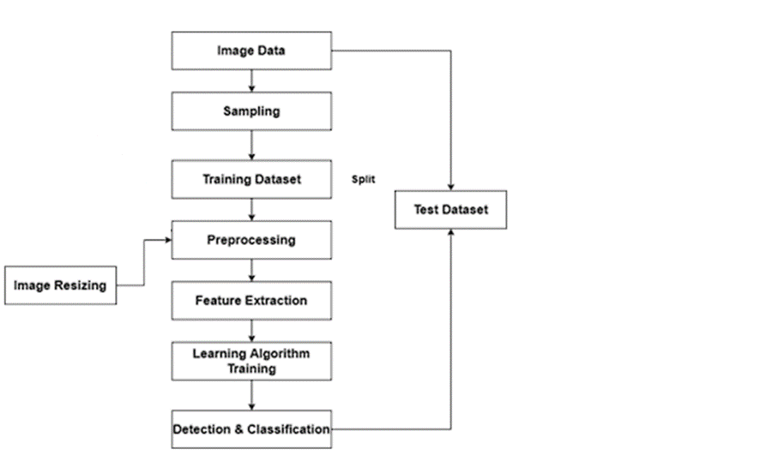

**Figure 8 : Work flow of Xception CNN model**

1. **Results and Discussion:**

We further split the training data for validation in the ratio 90:10. We use Adam as a optimizer thus the learning accuracy used for all the models is 0.0001 by default .

First we train the model for 30 epochs and 16 batches. We get a training accuracy of 91% , test accuracy of 71 % and validation accuracy of 70% . The loss is 4.13 and the validation loss is 4.73.

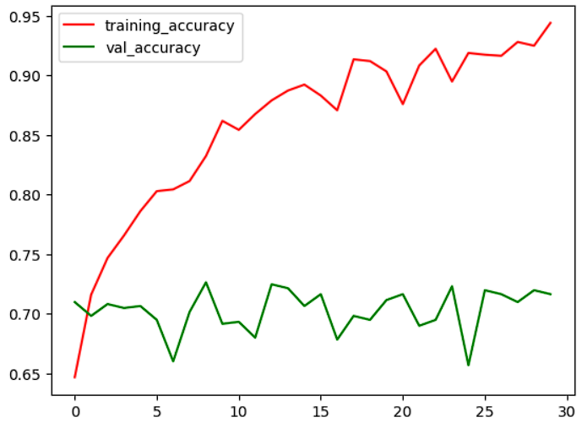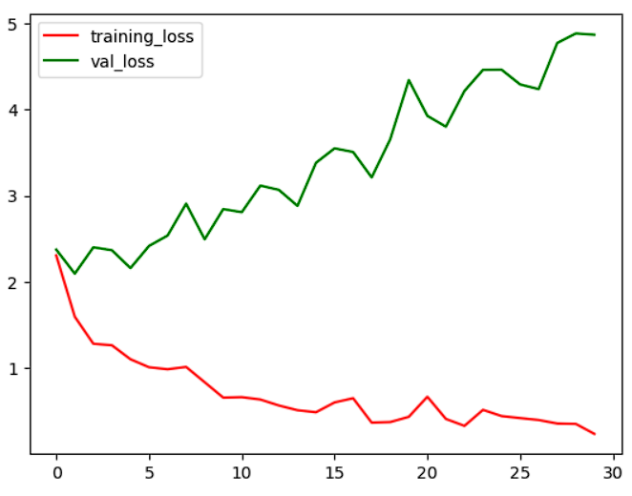

**Figure 9 : This represents the training and validation accuracy over the number of epochs**

The confusion matrix for the first model and its classification report is displayed below:

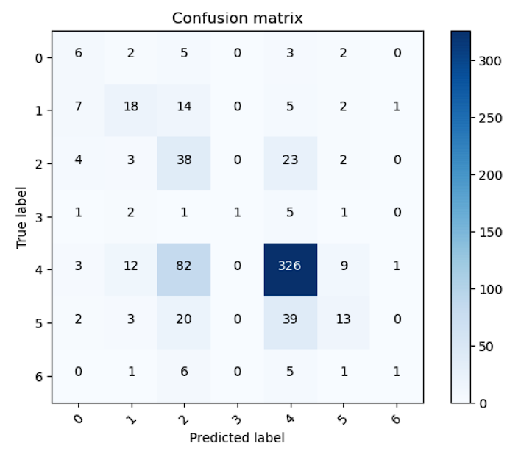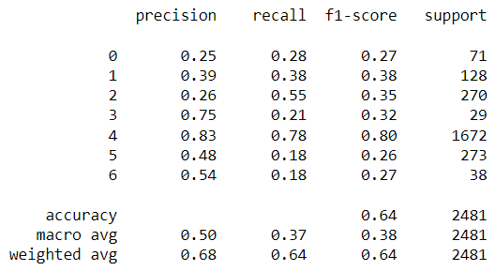

**Figure 10 : This represents the confusion matrix and classification report**

Then we train the model for both 20 epochs for the same batch size.For the first, we get a training accuracy of 96%, testing accuracy of 69% and validation accuracy of 66%. The loss is

5.05 and validation loss is 5.74 .

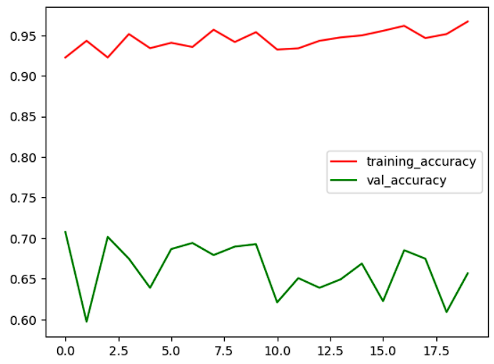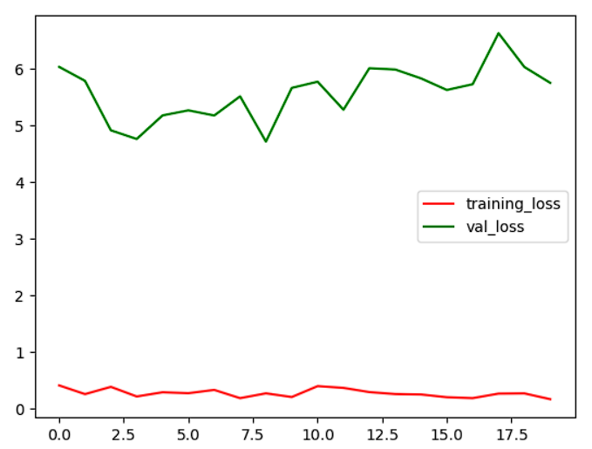

**Figure 11 : This represents the training and validation accuracy over the number of epochs**

The confusion matrix and classification matrix for the above model is given below:

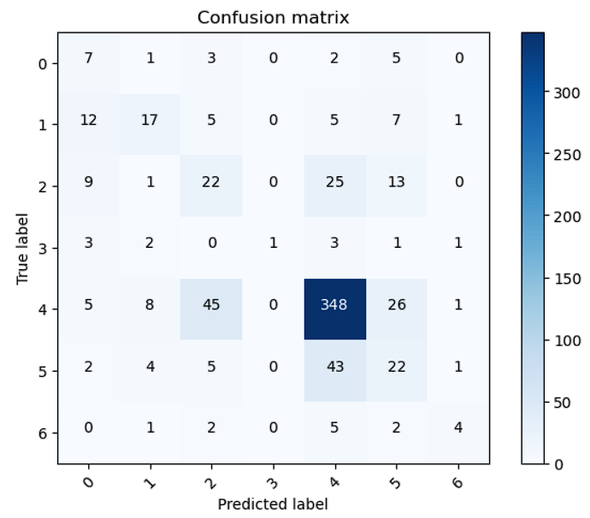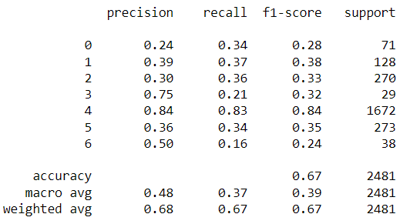

**Figure 12 : This represents the confusion matrix and classification report**

**Conclusions:**

Collaboration between the medical community and AI researchers is vital. Integrating AI-powered skin cancer detection into clinical practice requires validation, regulatory compliance, and ongoing collaboration with dermatologists and healthcare providers.

The success of CNN based detection can be attributed to high quality datasets. The importance of continuously improving and expanding these datasets cannot be overstated.

CNNs have demonstrated their effectiveness in accurately detecting skin cancer lesions from dermatological images. The utilization of deep learning techniques has the potential to significantly enhance early diagnosis rates, reducing the risk associated with delayed detection and treatment.

**List of Abbreviations:**

CNN : Convolution Neural Network

HAM : Human Against Machine

**Declarations:**

**Availability of Data and Material**: The dataset used in this research is taken from the ViDIR dataverse under the Harvard Dataverse.

**Conflict of Interest**: The authors declare no conflict of interest.

**Funding**: This research received no specific grant from any funding agency in the public, commercial, or not-for-profit sectors.

**Authors' contributions:** This research has been carried out by Saraswata Mangal under the guidance of Dr. CP Koushik.

**Acknowledgements:** We would like to express our sincere gratitude to VIT Bhopal, their Mangament and the respective Dean of School of Computing science engineering and Artificial Intelligence (SCAI) for their invaluable contributions to this research. Their expertise, support, and encouragement were instrumental in the completion of this study.

**References:**

[1] Mahbod, A., Schaefer, G., Wang, C., Ecker, R., & Ellinge, I. (2019, May). Skin lesion classification using hybrid deep neural networks. In ICASSP 2019-2019 IEEE international conference on acoustics, speech and signal processing (ICASSP) (pp. 1229-1233). IEEE.

[2] M. Z. Ur Rehman, F. Ahmed, S. A. Alsuhibany, S. S. Jamal, M. Z. Ali, and J. Ahmad, ‘‘Classification of skin cancer lesions using explainable deep learning,’’ Sensors, vol. 22, no. 18, p. 6915, Sep. 2022.

[3] W. Gouda, N. U. Sama, G. Al-Waakid, M. Humayun, and N. Z. Jhanjhi, ‘‘Detection of skin cancer based on skin lesion images using deep learning,’’ Healthcare, vol. 10, no. 7, p. 1183, Jun. 2022.

[4] Fu’adah, Y. N., Pratiwi, N. C., Pramudito, M. A., & Ibrahim, N. (2020, December). Convolutional neural network (cnn) for automatic skin cancer classification system. In IOP conference series: materials science and engineering (Vol. 982, No. 1, p. 012005). IOP Publishing.

[5] J. R. Hagerty, R. J. Stanley, H. A. Almubarak, N. Lama, R. Kasmi, P. Guo, R. J. Drugge, H. S. Rabinovitz, M. Oliviero, and W. V. Stoecker, ‘‘Deep learning and handcrafted method fusion: Higher diagnostic accuracy for melanoma dermoscopy images,’’ IEEE J. Biomed. Health Informat., vol. 23, no. 4, pp. 1385–1391, Jul. 2019.

[6] P. Tschandl, C. Rosendahl, and H. Kittler, ‘‘The HAM10000 dataset, a large collection of multi-source dermatoscopic images of common pigmented skin lesions,’’ Scientific Data, vol. 5, no. 1, pp. 1–9, Aug. 2018.

[7] Y. Fujisawa, Y. Otomo, Y. Ogata, Y. Nakamura, R. Fujita, Y. Ishitsuka, R. Watanabe, N. Okiyama, K. Ohara, and M. Fujimoto, ‘‘Deep-learningbased, computer-aided classifier developed with a small dataset of clinical images surpasses board-certified dermatologists in skin tumour diagnosis,’’ Brit. J. Dermatology, vol. 180, no. 2, pp. 373–381, Feb. 2019.

[8] A. G. C. Pacheco and R. A. Krohling, ‘‘The impact of patient clinical information on automated skin cancer detection,’’ Comput. Biol. Med., vol. 116, Jan. 2020, Art. no. 103545.

[9] S. Maqsood and R. Damaševičius, ‘‘Multiclass skin lesion localization and classification using deep learning based features fusion and selection framework for smart healthcare,’’ Neural Netw., vol. 160, pp. 238–258, Mar. 2023.

[10]Mridha, Krishna, Md Mezbah Uddin, Jungpil Shin, Susan Khadka, and M. F. Mridha. "An Interpretable Skin Cancer Classification Using Optimized Convolutional Neural Network for a Smart Healthcare System." *IEEE Access* (2023).H. L. GURURAJ ,

[11] U.-O. Dorj, K.-K. Lee, J.-Y. Choi, and M. Lee, ‘‘The skin cancer classification using deep convolutional neural network,’’ Multimedia Tools Appl., vol. 77, no. 8, pp. 9909–9924, Apr. 2018.

[12] A. Ameri, ‘‘A deep learning approach to skin cancer detection in dermoscopy images,’’ J. Biomed. Phys. Eng., vol. 10, no. 6, pp. 801–806, Dec. 2020.

[13] O. O. Abayomi-Alli, R. Damaševičius, S. Misra, R. Maskeliunas, and A. Abayomi-Alli, ‘‘Malignant skin melanoma detection using image augmentation by oversampling in nonlinear lower-dimensional embedding manifold,’’ TURKISH J. Electr. Eng. Comput. Sci., vol. 29, no. SI-1, pp. 2600–2614, Oct. 2021.

[14]M. Nawaz, T. Nazir, M. Masood, F. Ali, M. A. Khan, U. Tariq, N. Sahar, and R. Damaševičius, ‘‘Melanoma segmentation: A framework of improved DenseNet77 and UNET convolutional neural network,’’ Int. J. Imag. Syst. Technol., vol. 32, no. 6, pp. 2137–2153, Nov. 2022.

[15] Riaz, L., Qadir, H. M., Ali, G., Ali, M., Raza, M. A., Jurcut, A. D., & Ali, J. (2023). A Comprehensive Joint Learning System to Detect Skin Cancer. IEEE Access.

[16] Gururaj, H. L., Manju, N., Nagarjun, A., Aradhya, V. N. M., & Flammini, F. (2023). DeepSkin: a deep learning approach for skin cancer classification. IEEE Access.